**DSA Assignment – 1st July**

**Name – Karan Joshi**

**Roll No. – 23/11/EC/036**

**Leetcode Id – Karan_Joshi068048**

**Geeksforgeeks Id – wwwjoshikaran3424**

**Github Repo Link -** [**https://github.com/KaranJoshi101/urban-octo-robot/**](https://github.com/KaranJoshi101/urban-octo-robot/)

DSA-Section -

Question 1: Design Queue using Arrays

Code:

class Queue:

def __init__(self, size):

self.queue = []

self.size = size

def isEmpty(self):

return not len(self.queue)

def enqueue(self, x):

if len(self.queue) == self.size:

print("Queue Overflow")

else:

self.queue.append(x)

print(x, "successfully enqueued")

def dequeue(self):

if self.isEmpty():

print("Queue Underflow")

else:

x = self.queue.pop(0)

print(x, "successfully dequeued")

def front(self):

if self.isEmpty():

print("Queue is Empty")

else:

print("Front:",self.queue[0])

qu = Queue(3)

qu.enqueue(1)

qu.dequeue()

qu.dequeue()

qu.enqueue(1)

qu.enqueue(2)

qu.enqueue(3)

qu.enqueue(4)

qu.front()

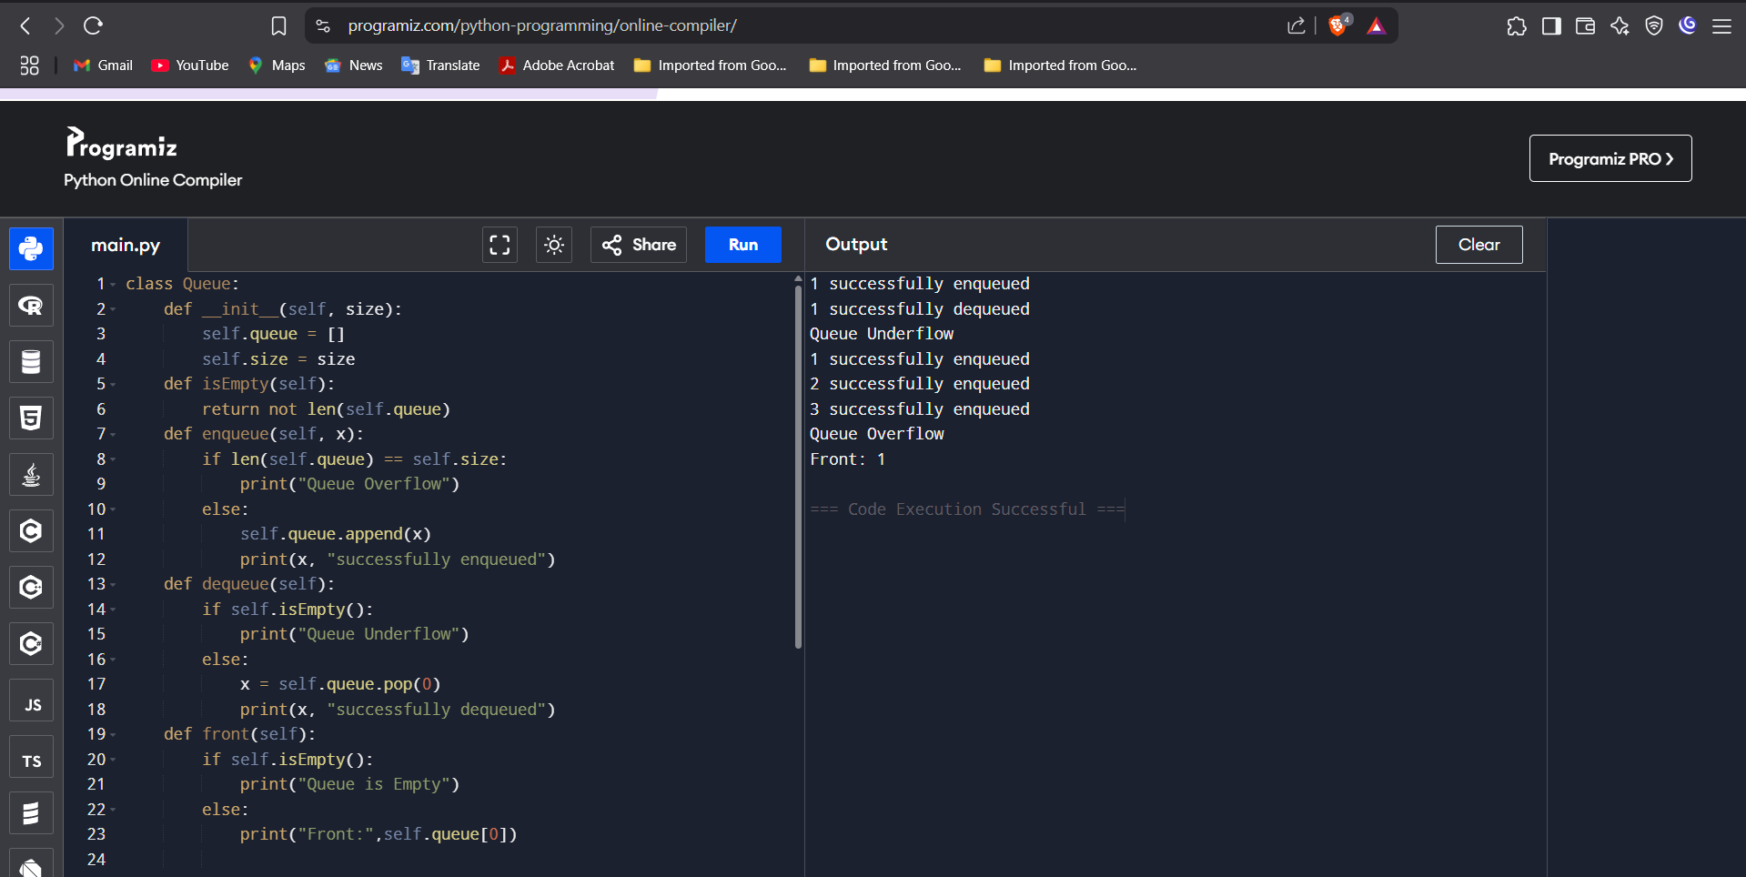

Question 2: Next Greater Element I

Platform: LeetCode

Problem Link: <https://leetcode.com/problems/next-greater-element-i/>

Submission Screenshot:

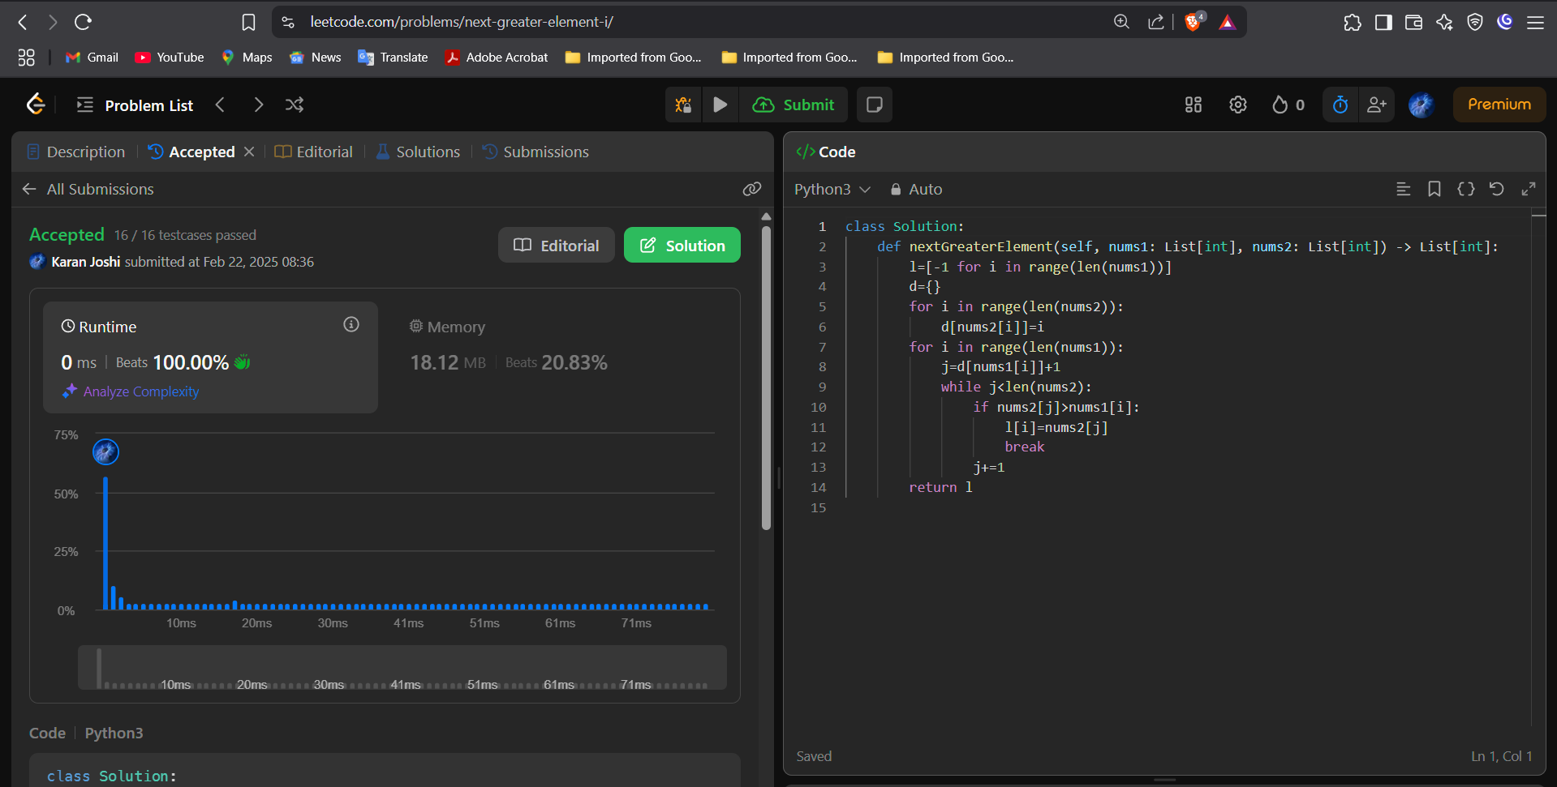

Question 3: Next Greater Element II

Platform: LeetCode

Problem Link: <https://leetcode.com/problems/next-greater-element-ii/description/>

Submission Screenshot:

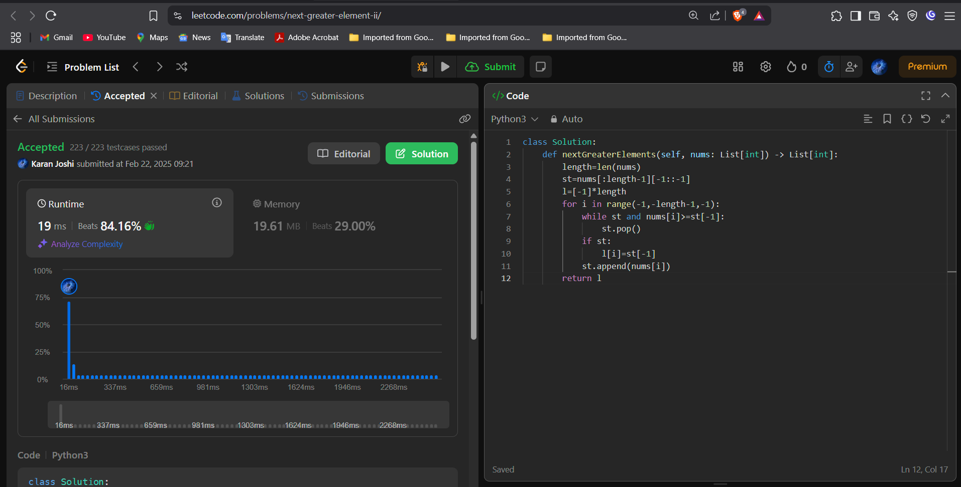



Question 4: Odd Even Linked List

Platform: LeetCode

Problem Link: <https://leetcode.com/problems/odd-even-linked-list/description/>

Submission Screenshot:

